Step by step instruction
How to Recover Your Password on the RigExpert Website (PC)
Step 1
Click the Log in button located in the top-right corner of the homepage.
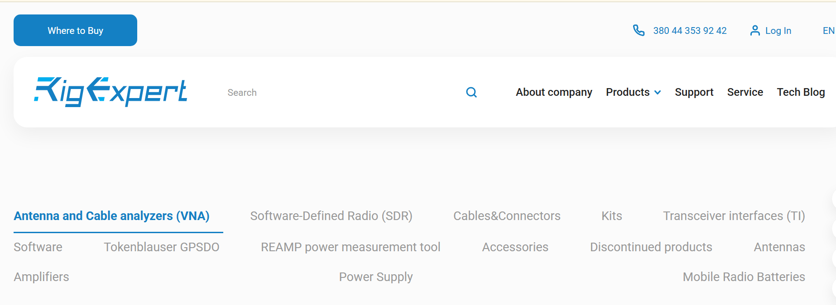
Step 2
Click the Remind password link.
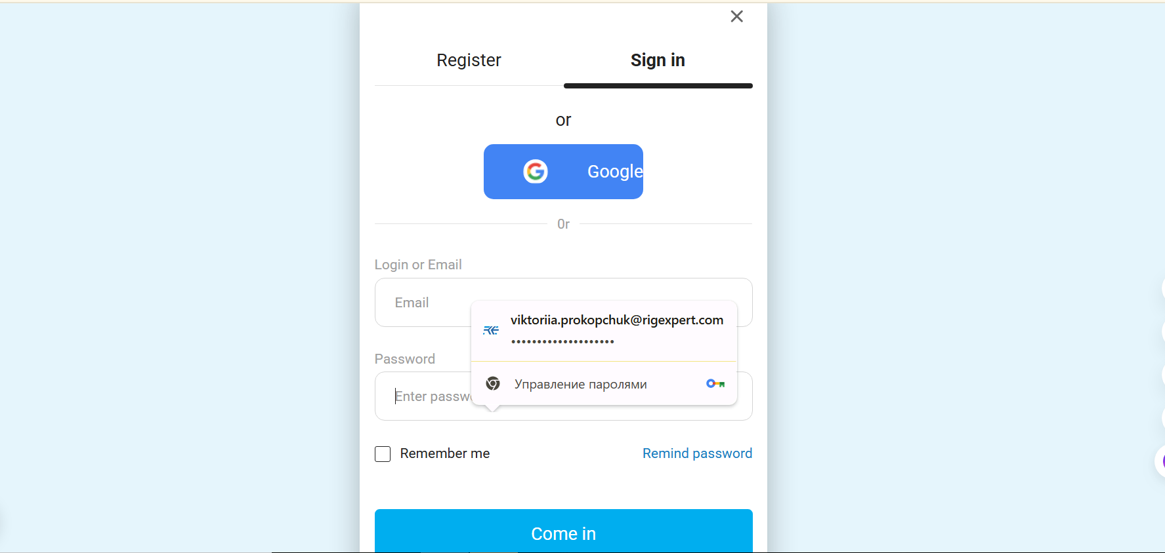
Step 3
Enter your email address into the provided field.
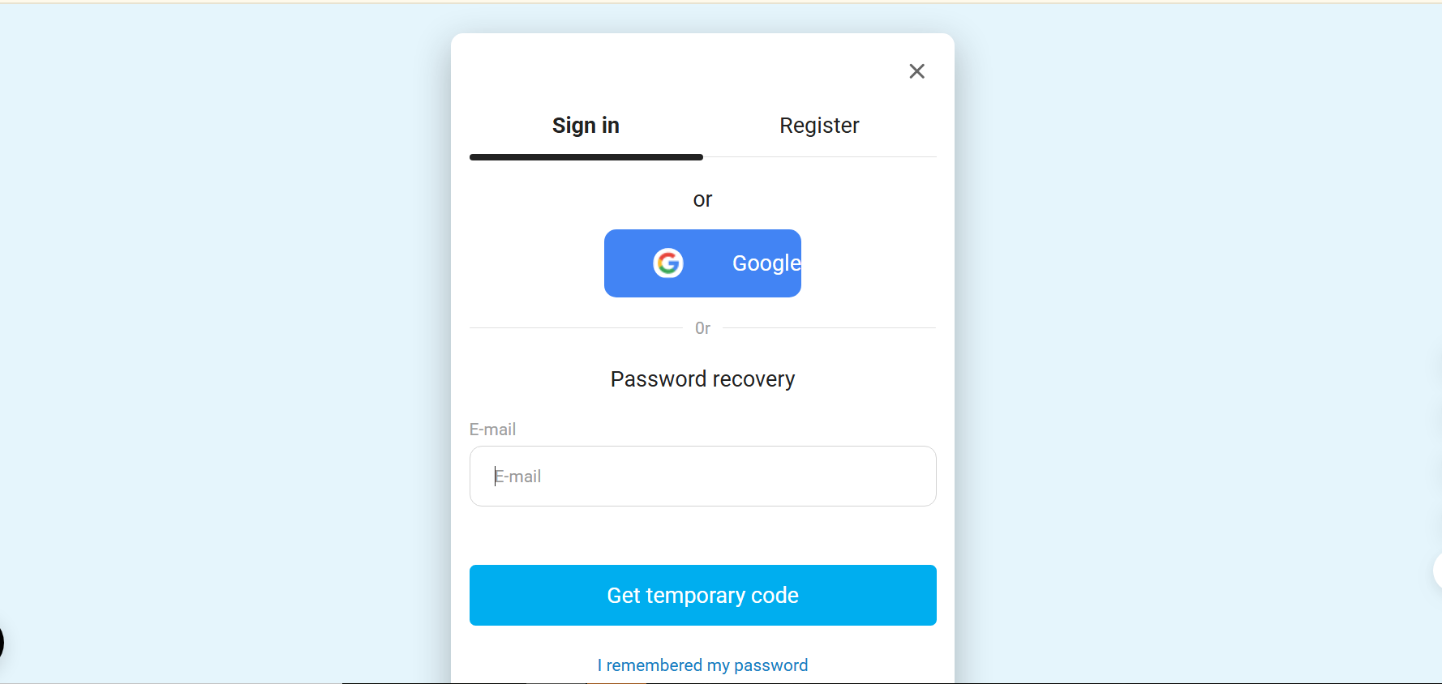
Step 4
Click the Get temporary code button.
Step 5
Check your email inbox for a message from RigExpert.
Copy the temporary code from the email.
Can’t find it? Double-check your email spelling and check your spam/junk folder.
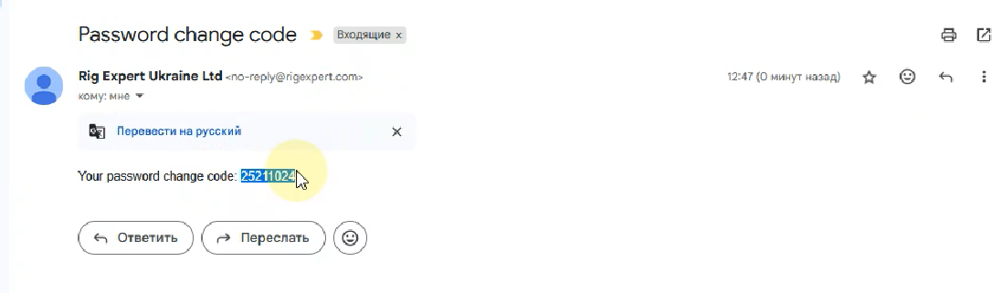
Step 6
Paste the temporary code from the email into the form on the website.
Enter your new password twice to confirm.

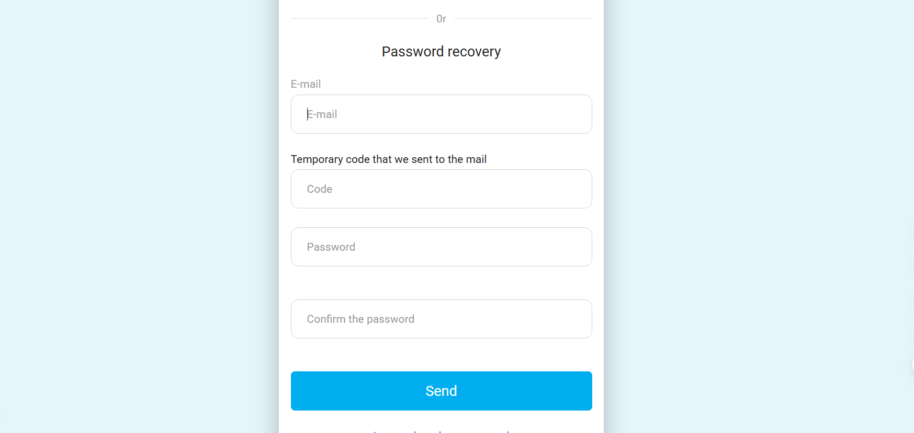
Step 6
Click the Send button.

✅ Done!
You’ll be automatically redirected to your RigExpert profile.
You can log out and log back in to confirm your new password works.
💡 Tip: Save your password in your browser for easier future access.

